**DESCENDING ORDER**  
**EXP NO: 13**

**AIM:**To compute descending order of an array using 8085 processor.

**ALGORITHM:**  
  
1)      Initialize HL pair as memory pointer.  
  
2)      Get the count at memory and load it into C register  
  
3)      Copy it in D register (for bubble sort (N-1)) times  
required).  
  
4)      Get the first value in A register.  
  
5)      Compare it with the value at next location.  
  
6)      If they are out of order, exchange the contents of A register  
and memory.  
  
7)      Decrement D register content by 1  
  
8)      Repeat step 5 and 7 till the value in D register become zero.  
  
9)      Decrement the C register content by 1.  
  
10)  Repeat steps 3 to 9 till the value in C register becomes  
zero.  
  
  
 **PROGRAM:**  
  
LOOP: LXI H,3500  
MVI D,00  
MVI C,05  
LOOP1: MOV A,M  
INX H  
CMP M  
JNC LOOP2  
MOV B,M  
MOV M,A  
DCX H  
MOV M,B  
INX H  
MVI D,01  
LOOP2: DCR C  
JNZ LOOP1  
MOV A,D  
RRC  
JC LOOP  
HLT

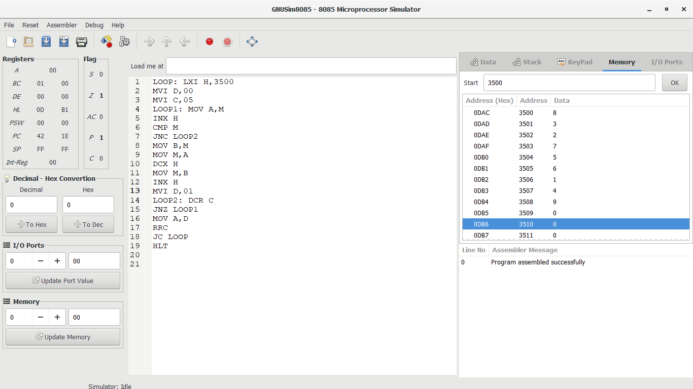**INPUT:**  
  
  
  
  
  
 

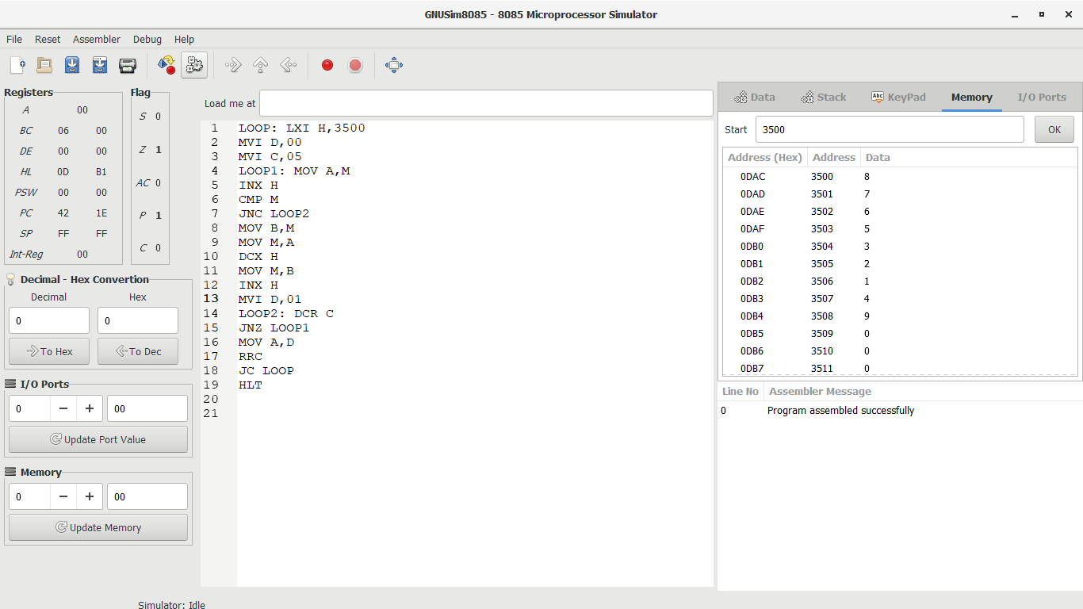  
  
**OUTPUT:**  
  
  
  
  
  
 

**RESULT:**Thus  
the program was executed successfully using 8085 processor simulator.